TravelMemory Application
Deployment on AWS EC2

Full-Stack MERN Application Deployment Project

Project | TravelMemory — MERN Stack Application
Stack | MongoDB · Express.js · React.js · Node.js
Cloud | Amazon Web Services (EC2, ALB)
DNS / CDN | Cloudflare
Name: Shubham Bhatnagar
Batch16A

Table of Contents
1. Introduction & Architecture Overview
2. Prerequisites
3. Task 1 — Backend Configuration
3.1 Launch EC2 Instance
3.2 Clone Repository & Install Dependencies
3.3 Configure Environment Variables
3.4 Configure Nginx Reverse Proxy
3.5 Start the Backend with PM2
4. Task 2 — Frontend Configuration & Backend Connection
4.1 Launch Frontend EC2 Instance
4.2 Update urls.js
4.3 Build & Serve the React App
5. Task 3 — Scaling & Load Balancing
5.1 Create AMIs from Running Instances
5.2 Launch Additional Instances
5.3 Create Target Groups
5.4 Create Application Load Balancer
6. Task 4 — Domain Setup with Cloudflare
6.1 Add Domain to Cloudflare
6.2 Create DNS Records
7. Security Best Practices
8. Troubleshooting
9. Architecture Diagram Description
10. References

1. Introduction & Architecture Overview
This document provides a step-by-step guide for deploying the TravelMemory MERN stack application on Amazon EC2. TravelMemory is a full-stack web application that allows users to record, manage, and share their travel memories. The deployment architecture follows industry best practices with separate frontend and backend instances, Nginx reverse proxy, an Application Load Balancer (ALB) for high availability, and Cloudflare for DNS management.

Architecture Summary
Component | Technology | Purpose
Frontend | React.js + Nginx | Serves the Single Page Application
Backend | Node.js + Express + Nginx | REST API on port 3000, proxied via Nginx
Database | MongoDB (Atlas or EC2) | Persistent data storage
Load Balancer | AWS ALB | Distributes traffic across instances
DNS / CDN | Cloudflare | Custom domain routing & DDoS protection

2. Prerequisites
Before beginning the deployment, ensure you have the following:

- AWS Account with appropriate IAM permissions (EC2, ALB, Security Groups)
- A registered domain name (e.g., yourdomain.com)
- Cloudflare account with your domain added
- MongoDB Atlas account OR a dedicated MongoDB EC2 instance
- Basic knowledge of Linux CLI, SSH, and AWS Console
- SSH key pair created in your AWS region
- Git installed on your local machine

EC2 Instance Specifications (Recommended)
- Instance Type: t2.micro (Free Tier) or t3.small for production
- AMI: Ubuntu Server 22.04 LTS (HVM), SSD Volume Type
- Storage: 8 GB gp3
- Security Group: Allow ports 22 (SSH), 80 (HTTP), 443 (HTTPS), 3000 (Node.js backend)

3. Task 1 — Backend Configuration

3.1 Launch EC2 Instance for Backend
Follow these steps in the AWS Management Console:

- Navigate to EC2 > Instances > Launch Instance.
- Set Name: Travelmem-EC2-Ist.
- Select AMI: Ubuntu Server 22.04 LTS.
- Choose Instance Type: t2.micro (or t3.small).
- Select or create a Key Pair for SSH access.
- Configure Security Group with the following inbound rules:
- SSH (port 22) — Your IP
- HTTP (port 80) — Anywhere (0.0.0.0/0)
- Custom TCP (port 3000) — Anywhere or ALB SG only
- Click Launch Instance and wait for the status check to pass.
- Note the Public IPv4 address for SSH access.
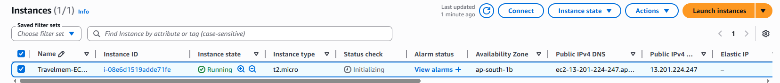

3.2 Connect, Clone Repository & Install Dependencies
SSH into your backend EC2 instance:
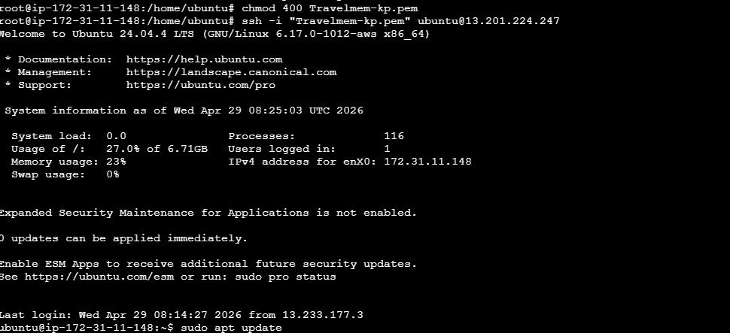
Update packages and install Node.js, npm, Git, and Nginx:
sudo apt update && sudo apt upgrade -y
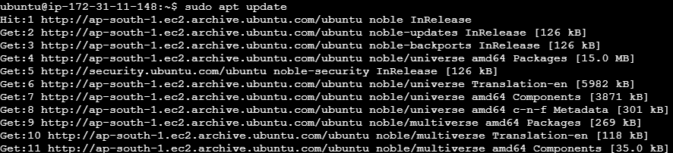
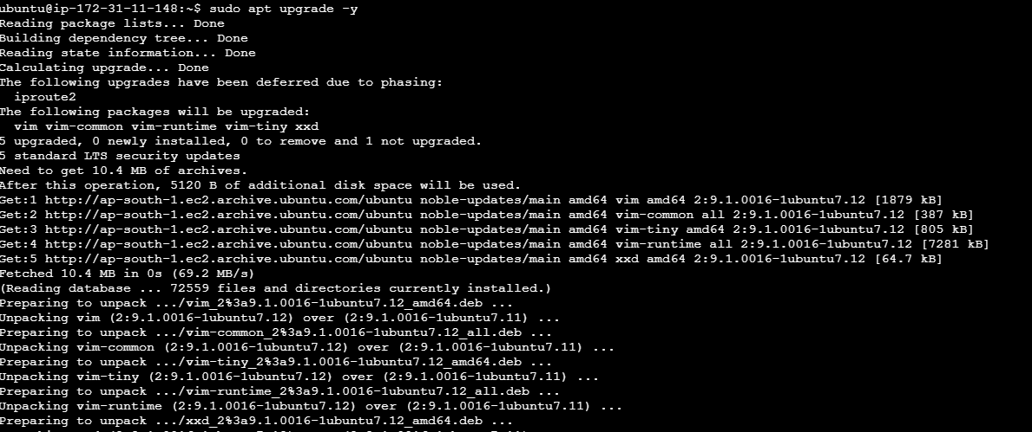
sudo apt install -y nodejs git nginx
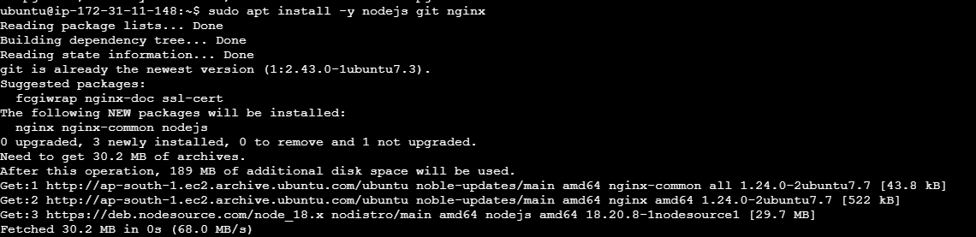
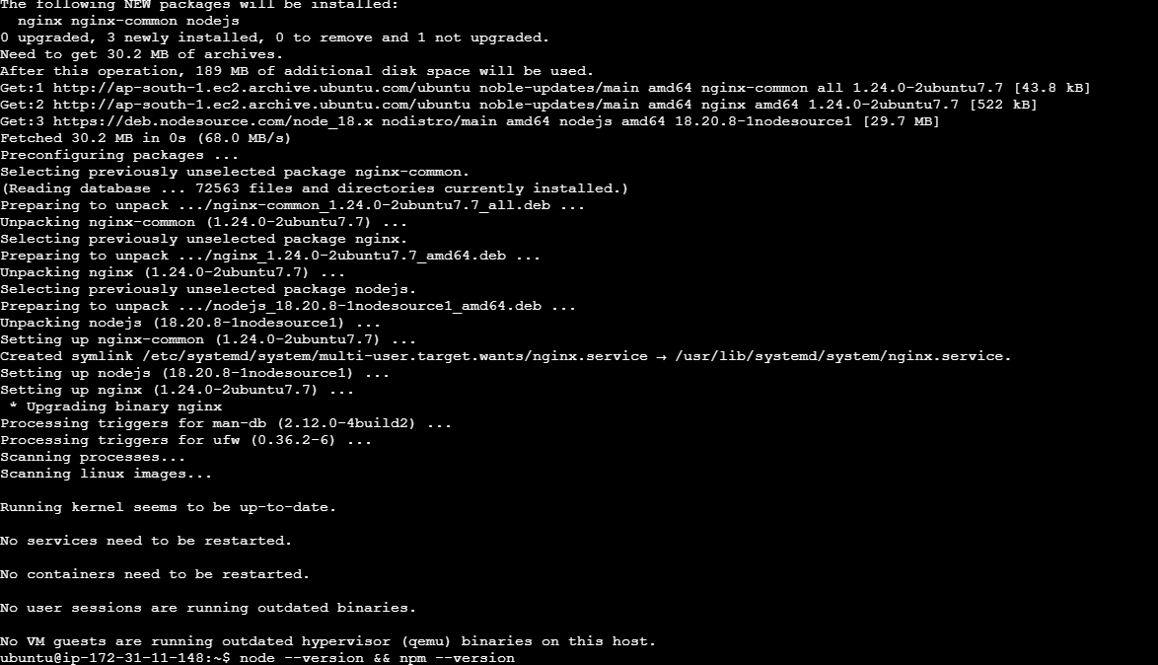
curl -fsSL https://deb.nodesource.com/setup_18.x | sudo -E bash -
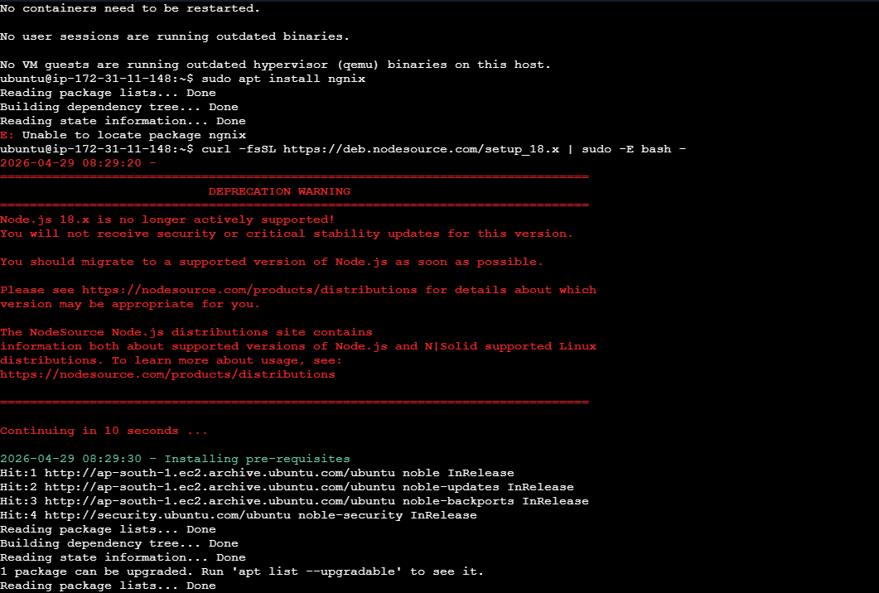
node --version && npm --version

Clone the TravelMemory repository:
git clone https://github.com/UnpredictablePrashant/TravelMemory.git
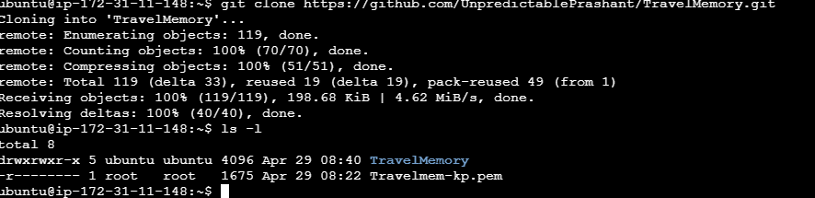
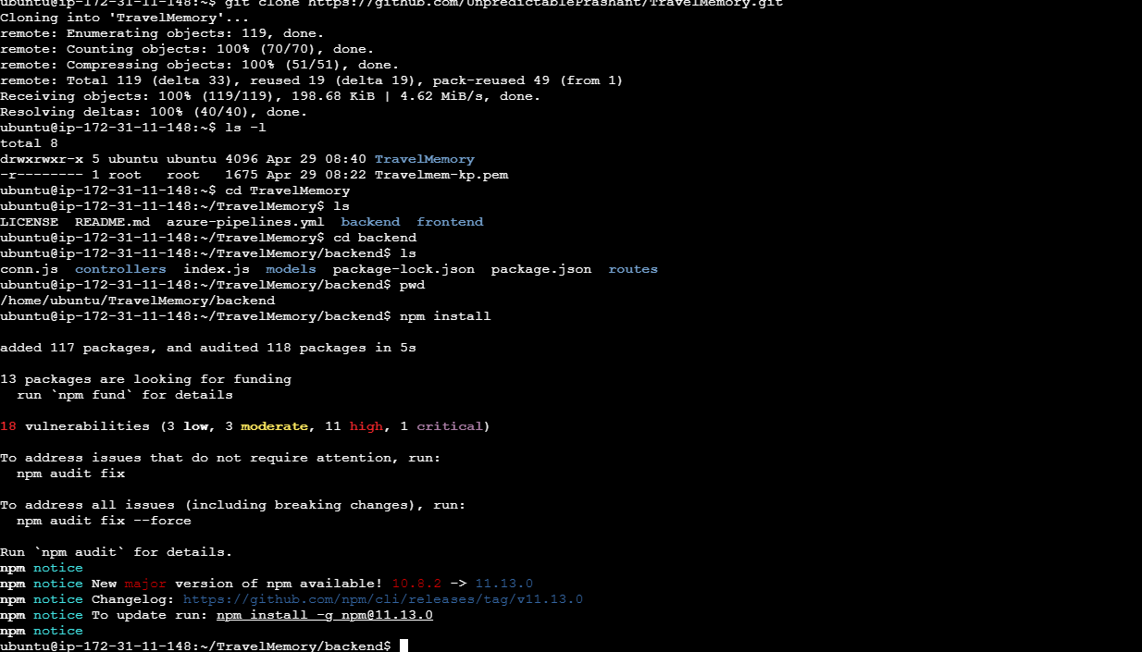
cd TravelMemory/backend
npm install

3.3 Configure Environment Variables (.env)
Create the .env file in the backend directory:
nano .env
Add the following configuration in the .env file:
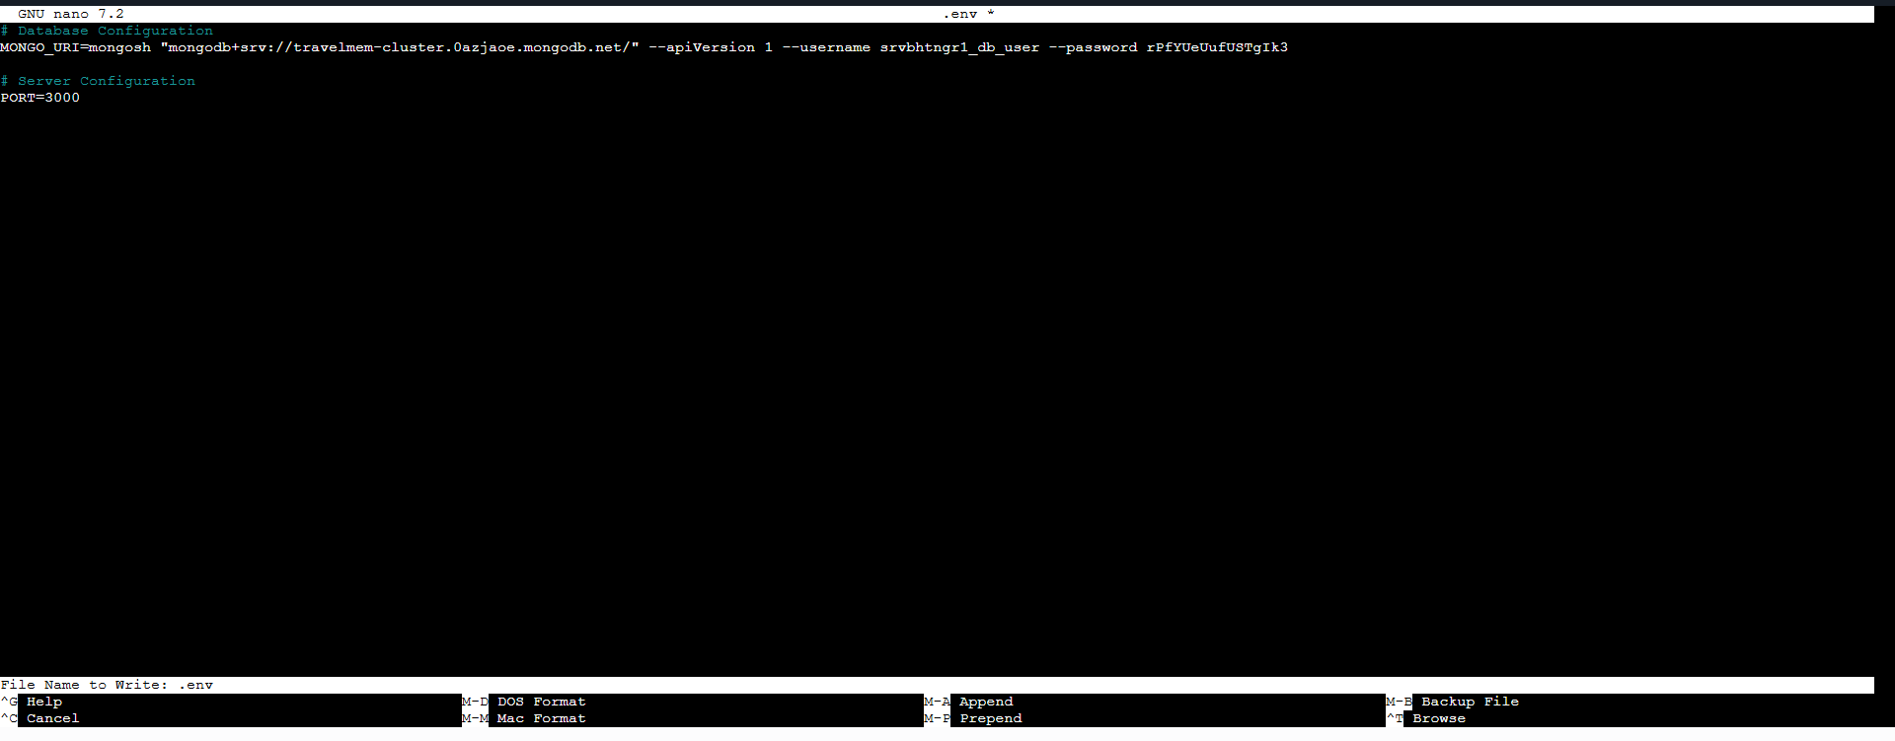

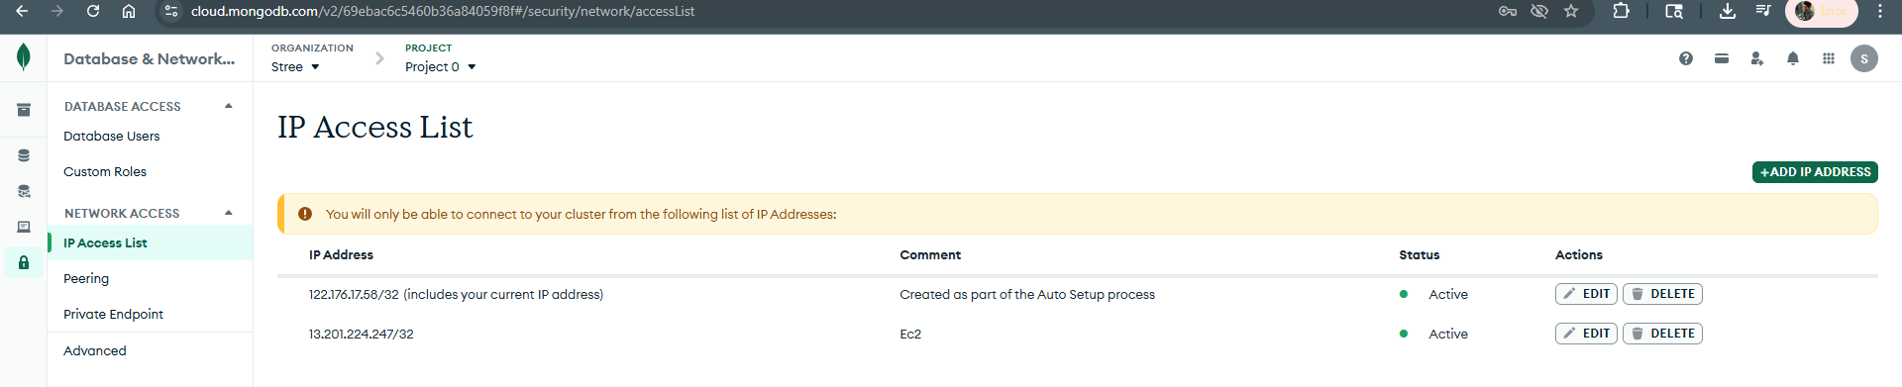
Whitelisted my EC2 instance IP in the Atlas Network Access settings.

3.4 Configure Nginx Reverse Proxy
Nginx will act as a reverse proxy, forwarding HTTP requests from port 80 to the Node.js application running on port 3000. This enables clean URLs and prepares for SSL termination.

Create a new Nginx configuration file:

sudo nano /etc/nginx/sites-available/travelmemory-backend

Below is the following configuration:

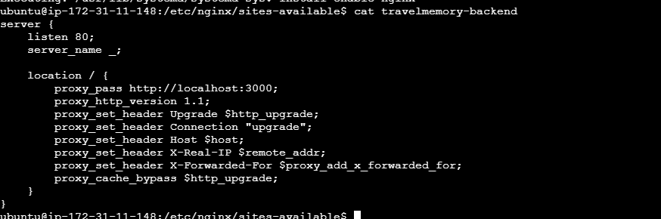
Enable the configuration and restart Nginx:
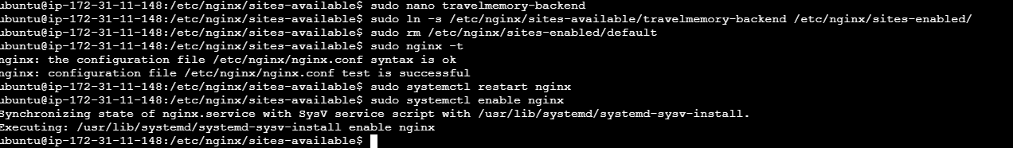

3.5 Start the Backend with PM2
PM2 is a production-grade process manager for Node.js that keeps the application running after SSH disconnections and auto-restarts on crashes.
sudo npm install -g pm2
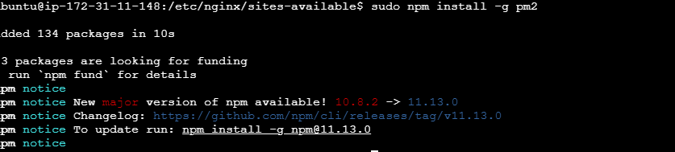
pm2 start index.js --name travelmemory-backend

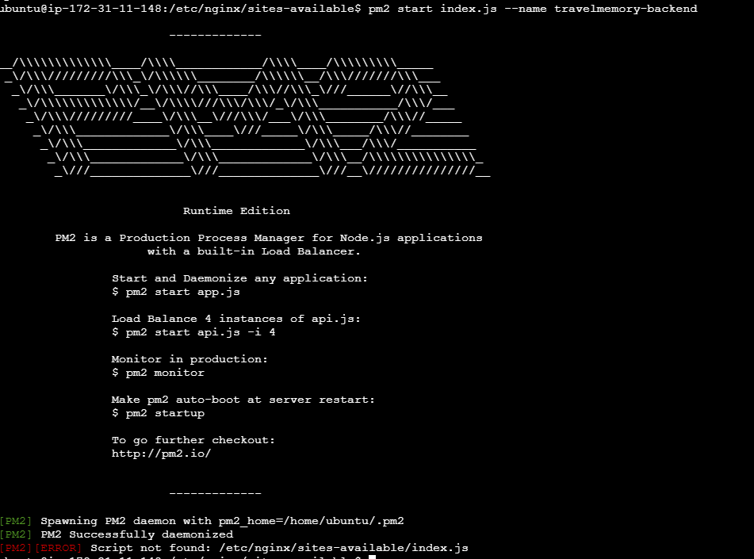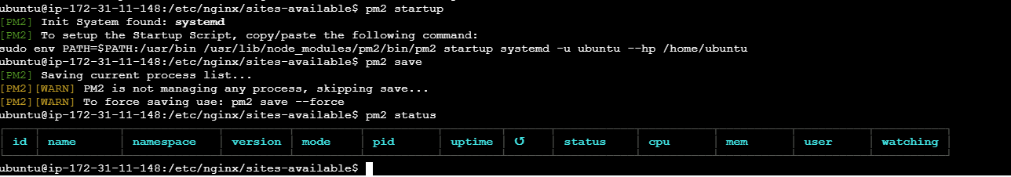
pm2 startup
pm2 save
pm2 status

4. Task 2 — Frontend Configuration & Backend Connection

4.1 Launch Frontend EC2 Instance
Repeat the EC2 launch steps from Section 3.1 with these differences:

- Name: TravelMemory-Frontend-1
- Security Group: Allow ports 22, 80, 443 only (no port 3000 needed)

SSH into the frontend instance and install dependencies:
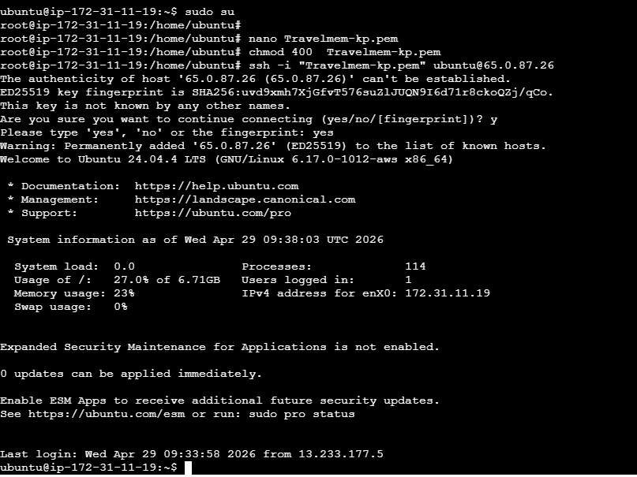
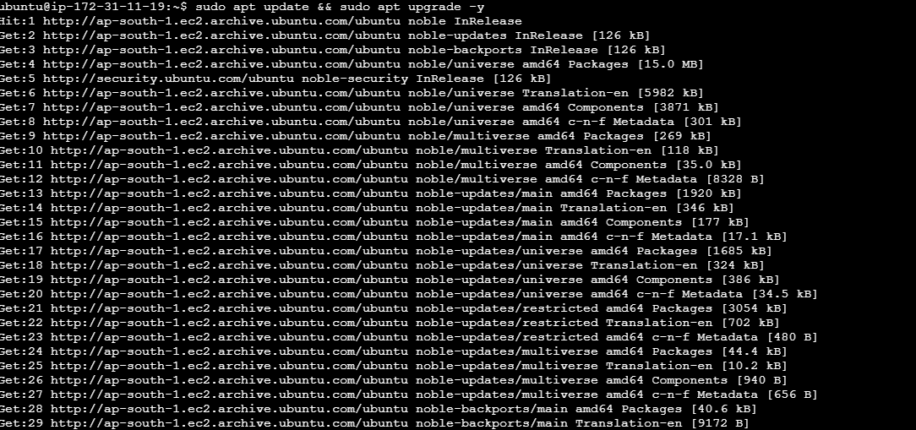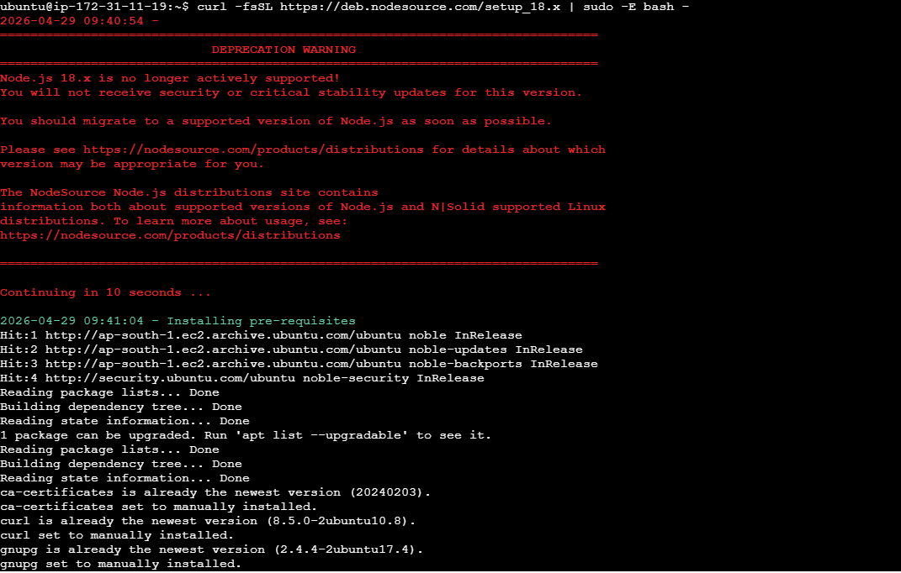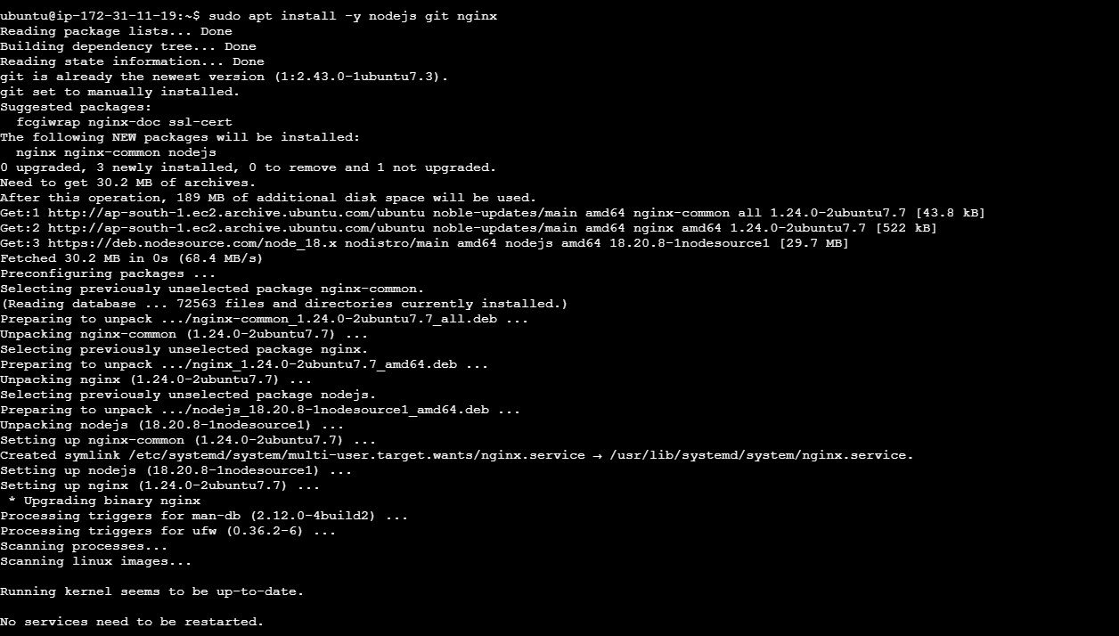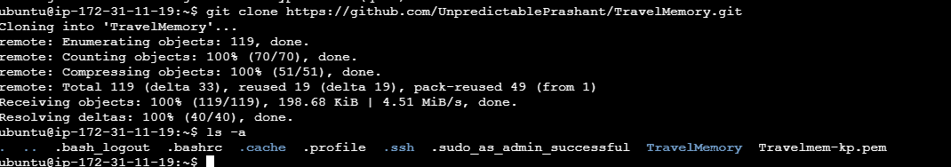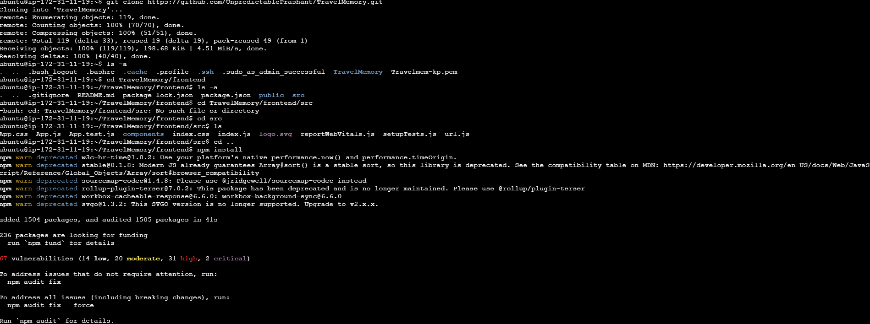
ssh -i "your-key.pem" ubuntu@<FRONTEND_PUBLIC_IP>
sudo apt update && sudo apt upgrade -y
curl -fsSL https://deb.nodesource.com/setup_18.x | sudo -E bash -
sudo apt install -y nodejs git nginx
git clone https://github.com/UnpredictablePrashant/TravelMemory.git
cd TravelMemory/frontend
npm install

4.2 Update urls.js to Connect Frontend to Backend
The frontend needs to know the URL of the backend API. Open the urls.js file and update it with your backend load balancer URL (or backend EC2 public IP for testing):

nano src/url.js

Update the file content:
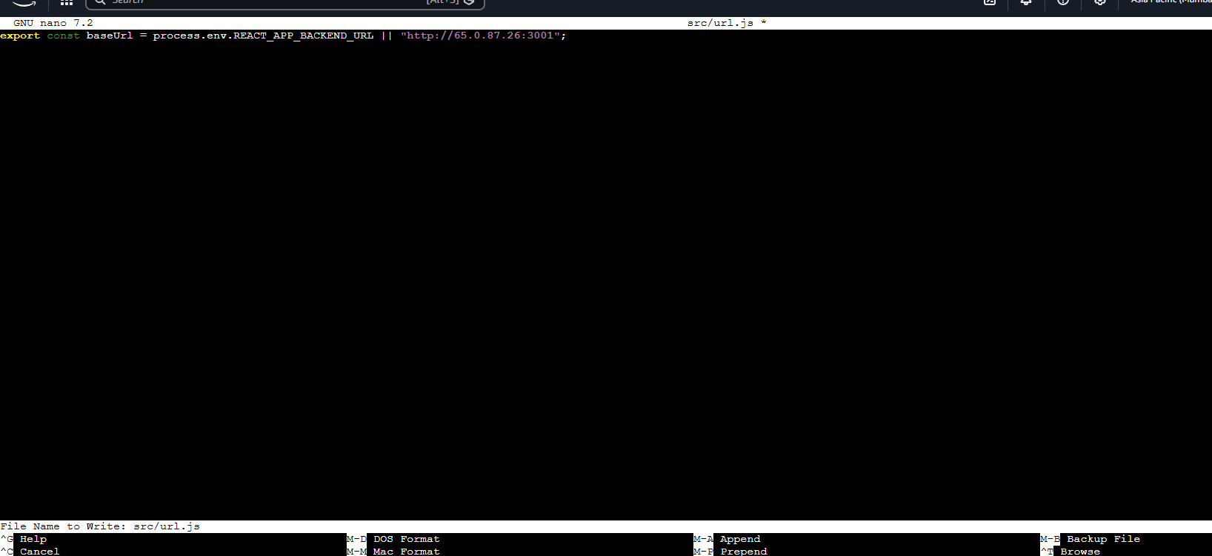
// src/url.js
// export const baseUrl = 'http://<BACKEND_EC2_PUBLIC_IP>';

4.3 Build the React App & Serve with Nginx
Build the production-optimized React bundle:
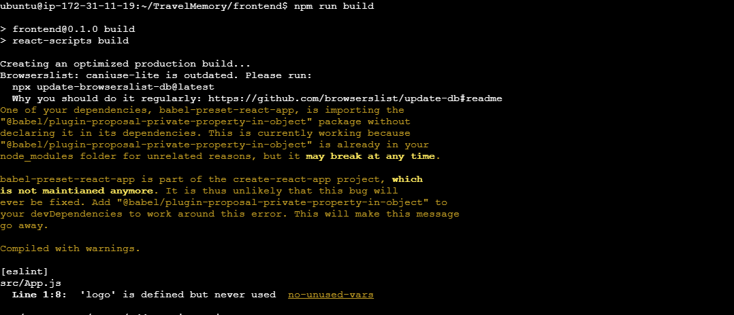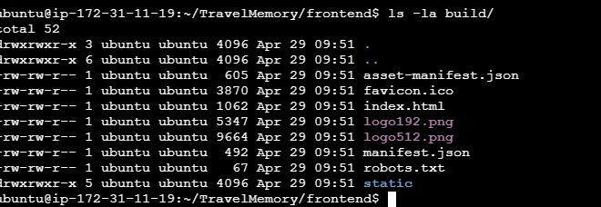
npm run build
ls -la build/

Configure Nginx to serve the React static files:
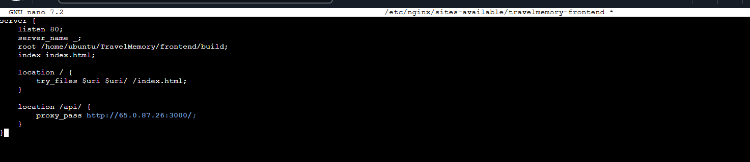

sudo nano /etc/nginx/sites-available/travelmemory-frontend
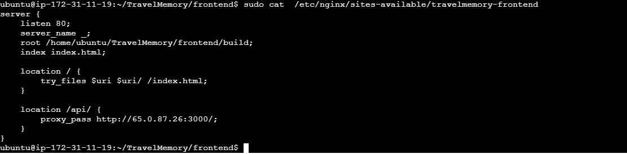
sudo ln -s /etc/nginx/sites-available/travelmemory-frontend /etc/nginx/sites-enabled/
sudo rm /etc/nginx/sites-enabled/default
sudo nginx -t && sudo systemctl restart nginx
Test the frontend by visiting http://<FRONTEND_PUBLIC_IP> in your browser.
Note: Screenshot Point: Screenshot of the TravelMemory application running in the browser via the EC2 public IP.

5. Task 3 — Scaling the Application & Load Balancing

5.1 Create AMIs from Running Instances
Amazon Machine Images (AMIs) allow you to quickly launch identical instances. Create an AMI from each running instance:

- In EC2 Console, select your Travelmem-EC2-Ist instance.
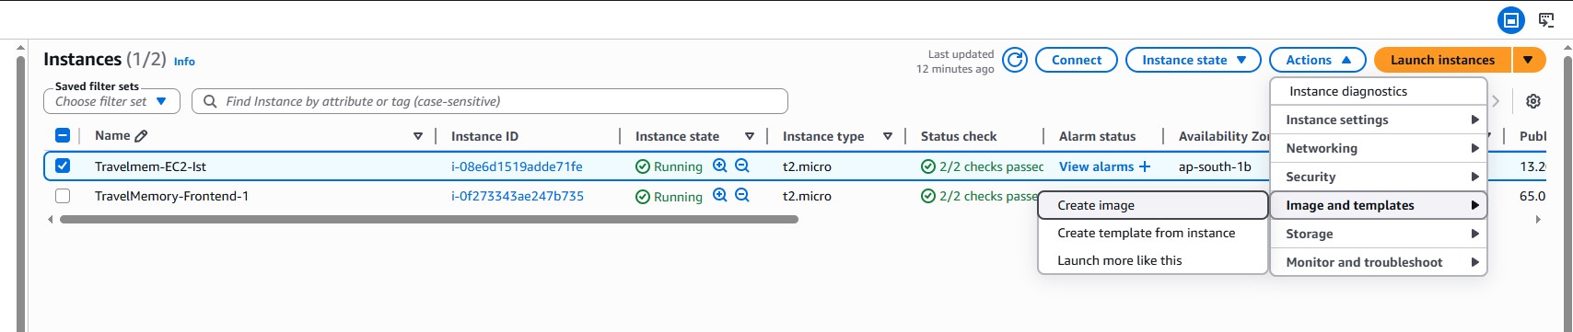
- Actions > Image and templates > Create image.
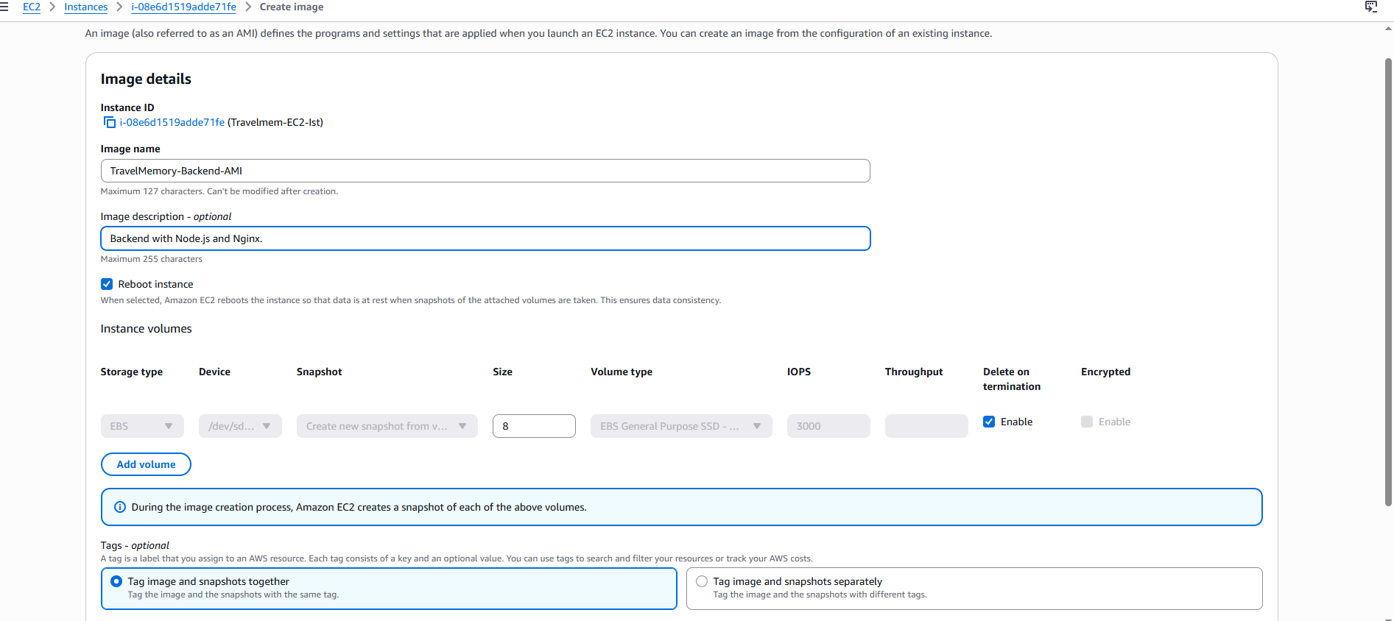
- Name: TravelMemory-Backend-AMI, Description: Backend with Node.js and Nginx.
- Click Create image. Repeat for the frontend instance.
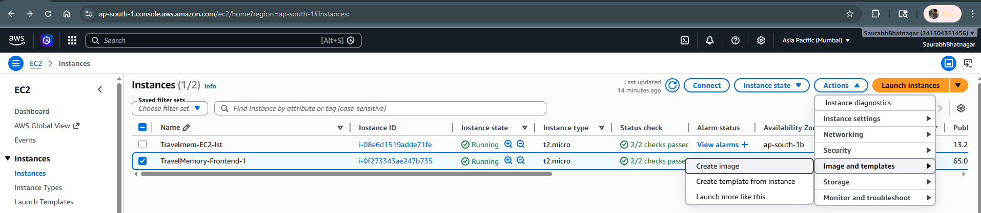
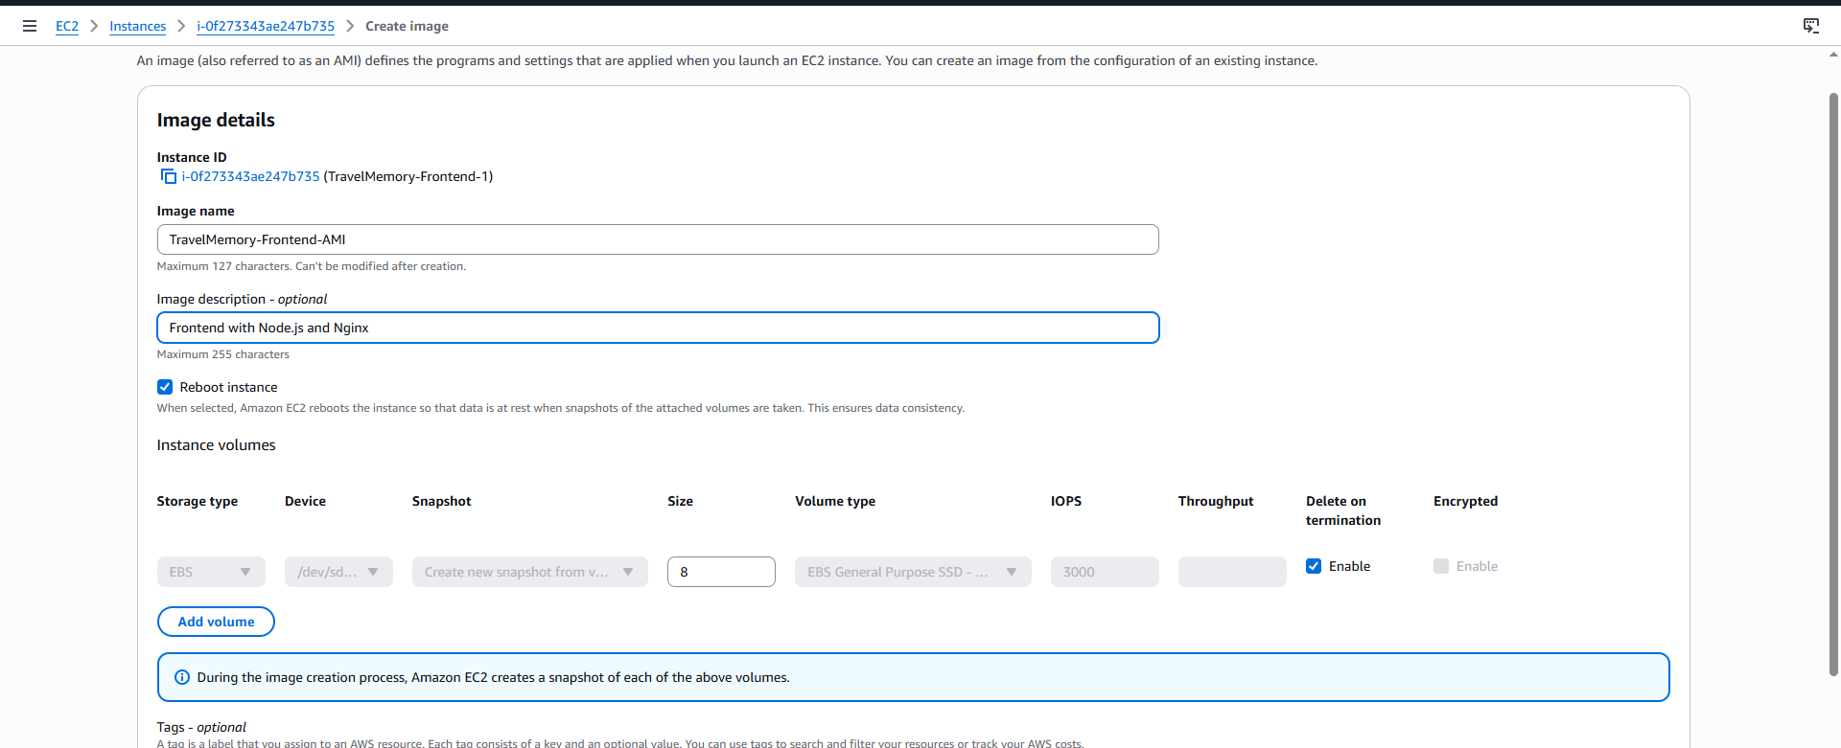
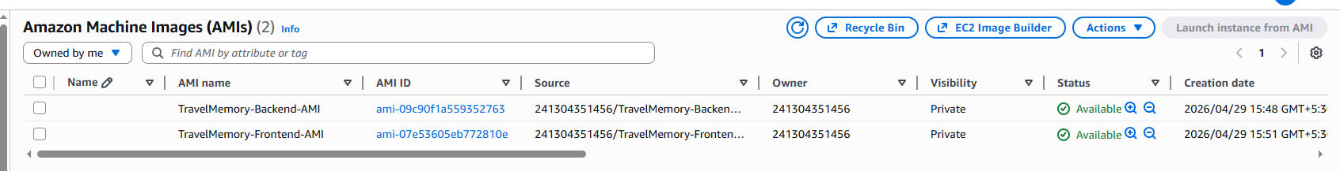
Note: Screenshot Point: Screenshot of the AMI creation dialog and the resulting AMI in the "AMIs" section with status "available".

5.2 Launch Additional Instances from AMIs
Launch at least one more backend and one more frontend instance from the AMIs:

- EC2 > AMIs > Select TravelMemory-Backend-AMI > Launch instance from AMI.
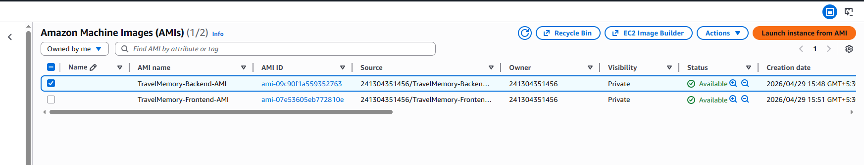
- Name: TravelMemory-Backend-2.
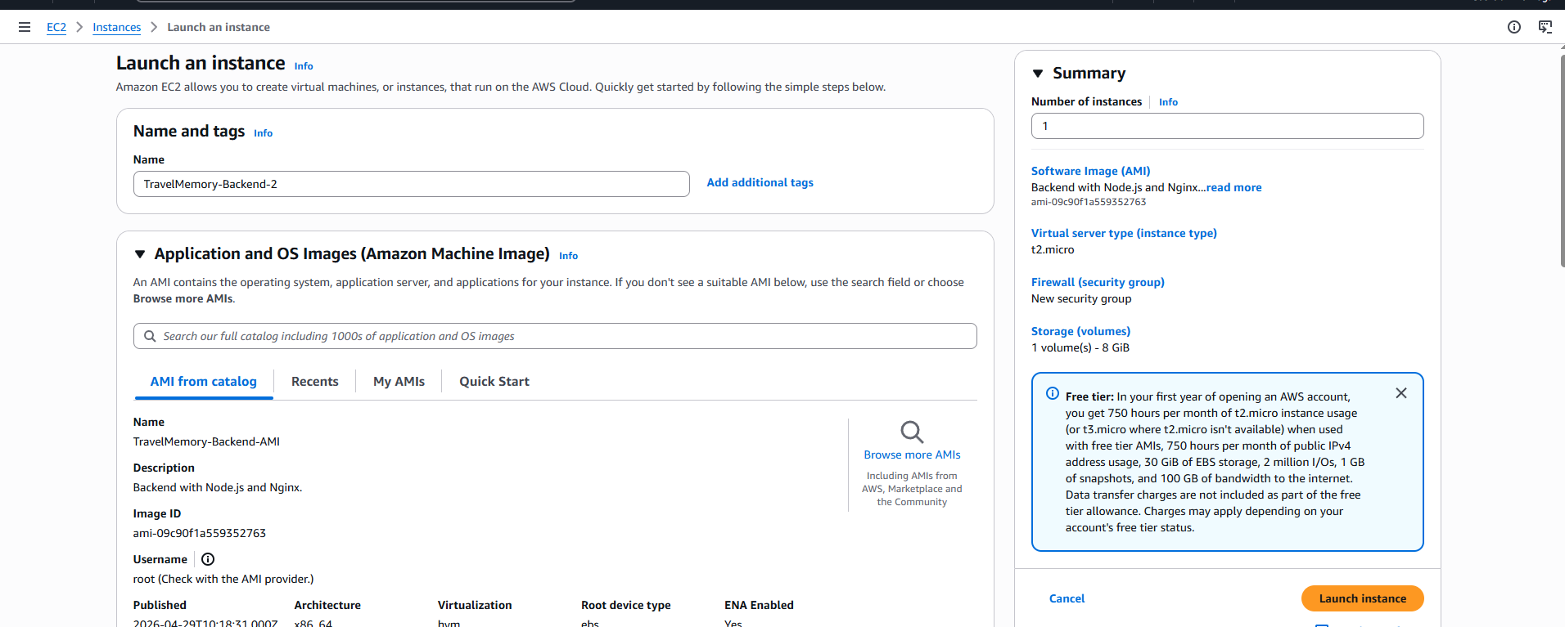
- Use the same instance type, key pair, and security group.
- Repeat to create TravelMemory-Frontend-2.
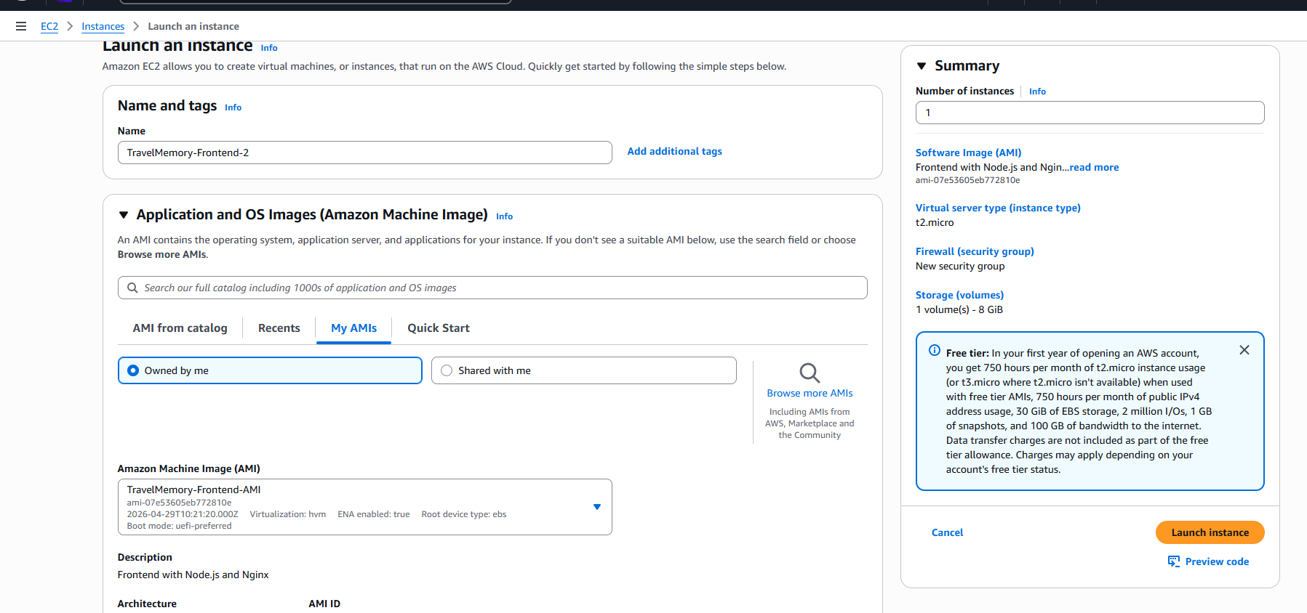

5.3 Create Target Groups
Target groups define where the load balancer sends traffic.

Create Backend Target Group:
- EC2 > Target Groups > Create target group.
- Target type: Instances, Protocol: HTTP, Port: 80.
- Name: TravelMemory-Backend-TG.
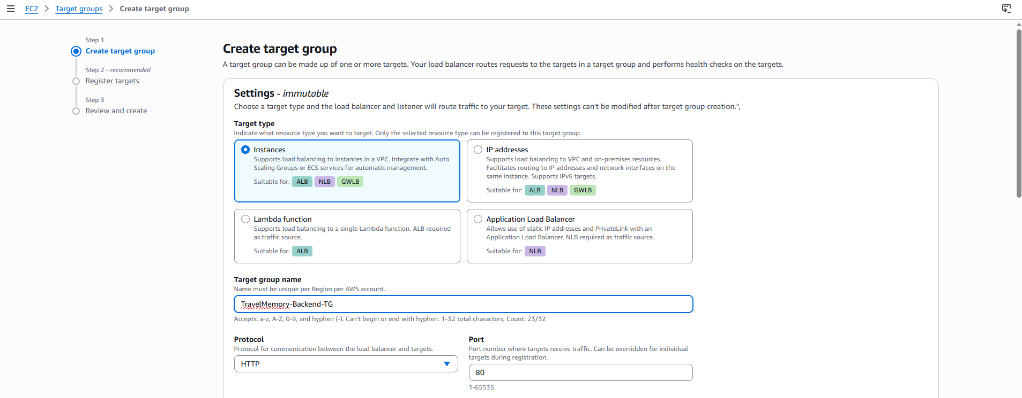
- Health check path: / (or /api/health if available).
- Register targets: Add Travelmem-EC2-Ist and TravelMemory-Backend-2.
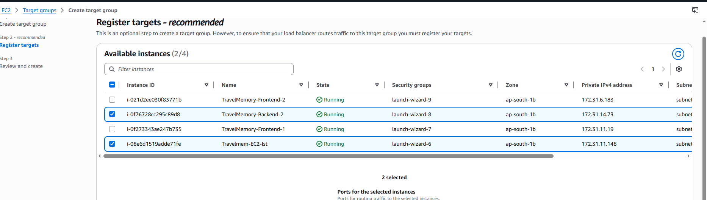
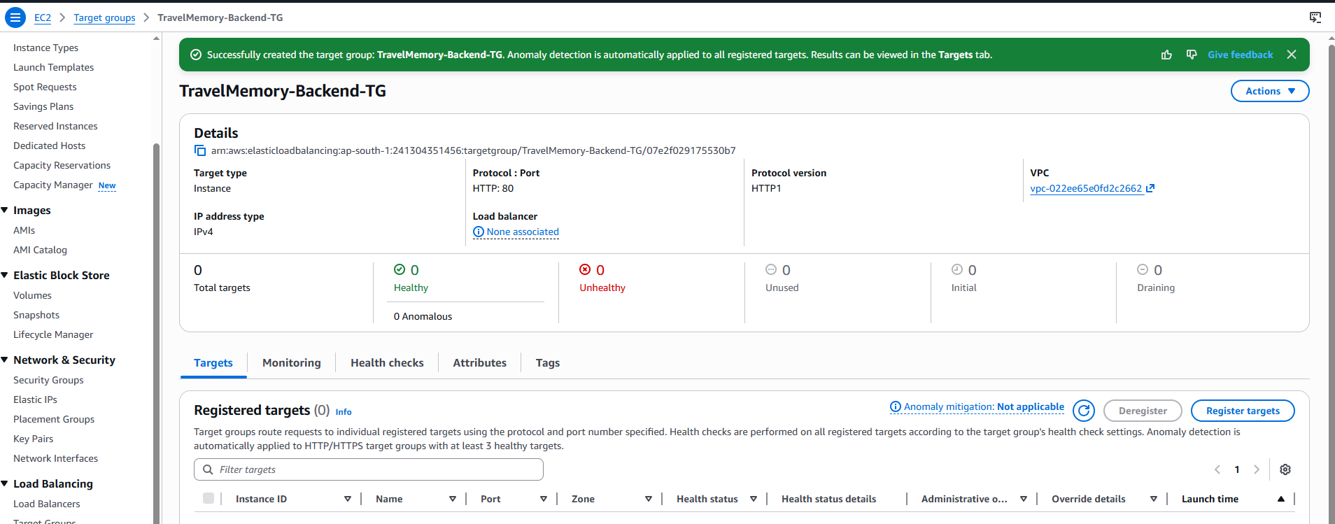

Create Frontend Target Group:
- Repeat the above with name TravelMemory-Frontend-TG.
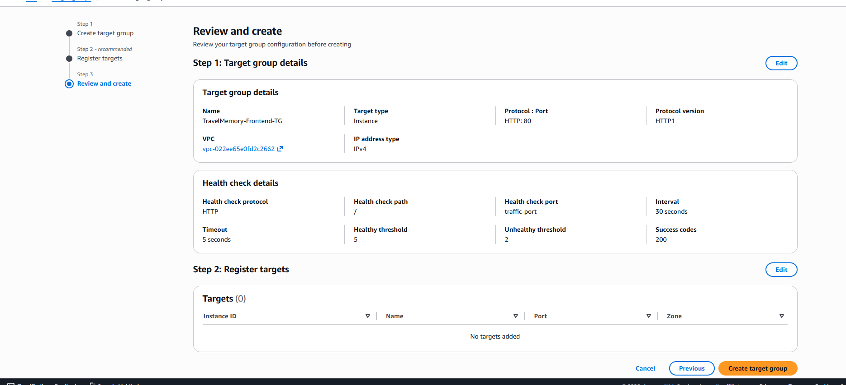
- Register TravelMemory-Frontend-1 and TravelMemory-Frontend-2.
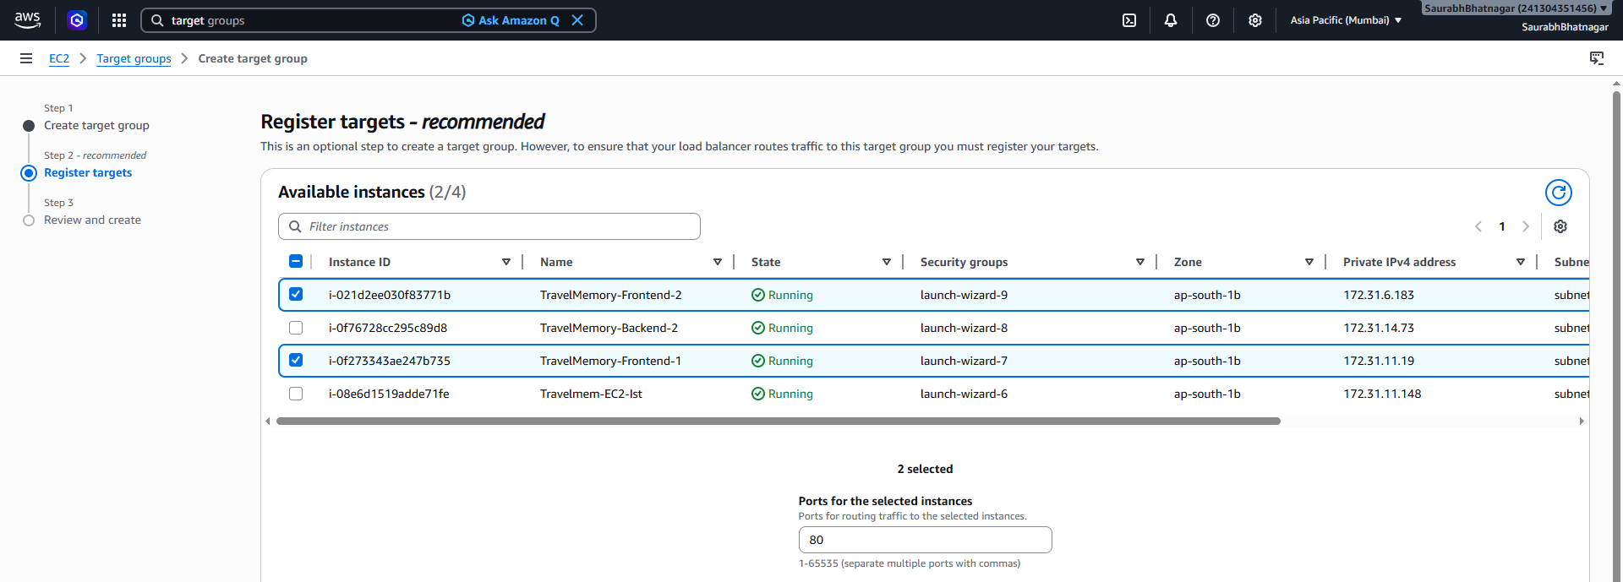
Note: Screenshot Point: Screenshot of both target groups showing all instances as "healthy".
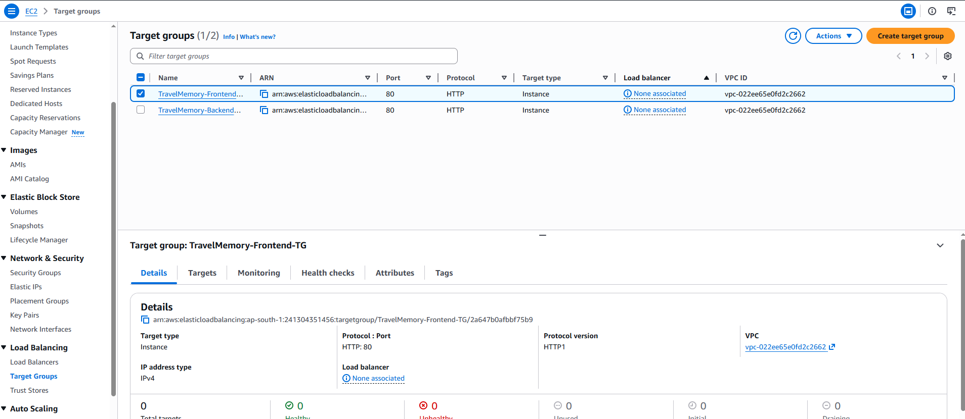

5.4 Create Application Load Balancer (ALB)
Create two ALBs — one for frontend, one for backend:

Backend Load Balancer:
- EC2 > Load Balancers > Create Load Balancer > Application Load Balancer.
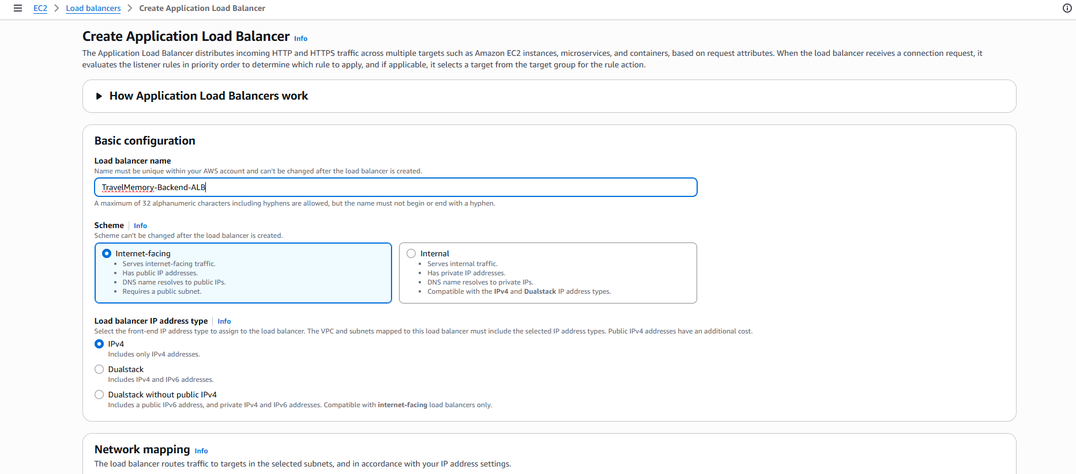
- Name: TravelMemory-Backend-ALB.
- Scheme: Internet-facing, IP type: IPv4.
- Select at least 2 Availability Zones and subnets.
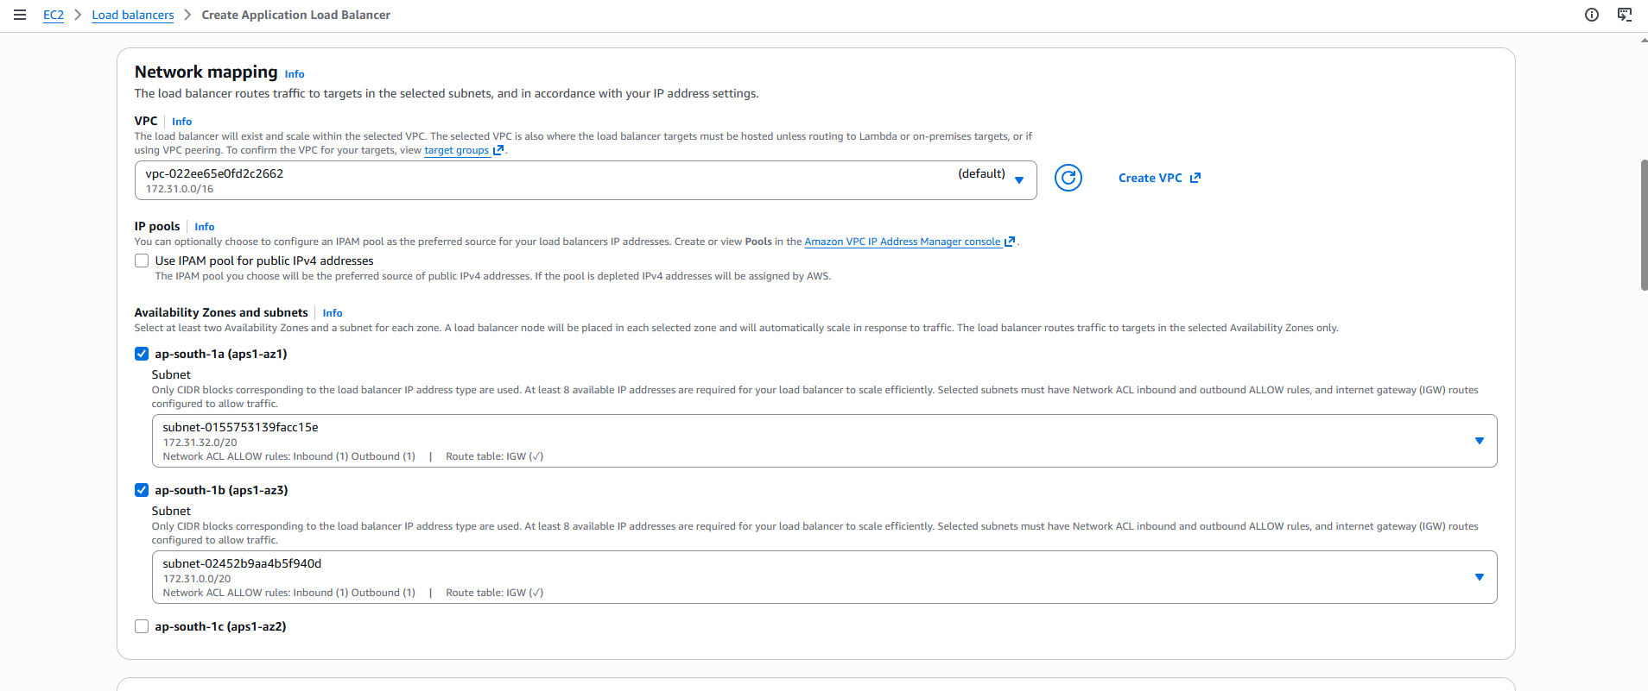
- Security Group: Allow inbound HTTP (80) and HTTPS (443).
- Listener: HTTP:80 > Forward to TravelMemory-Backend-TG.
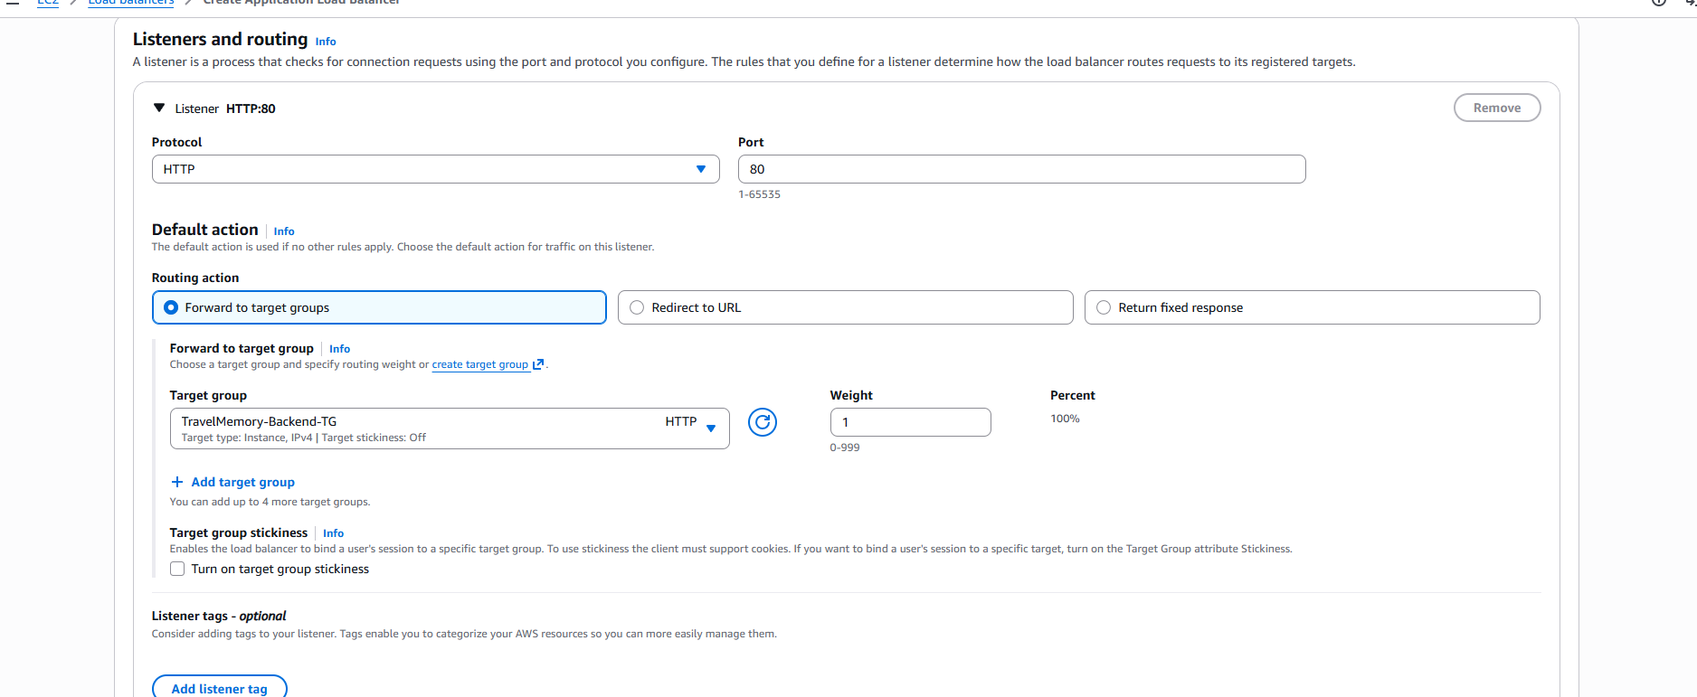
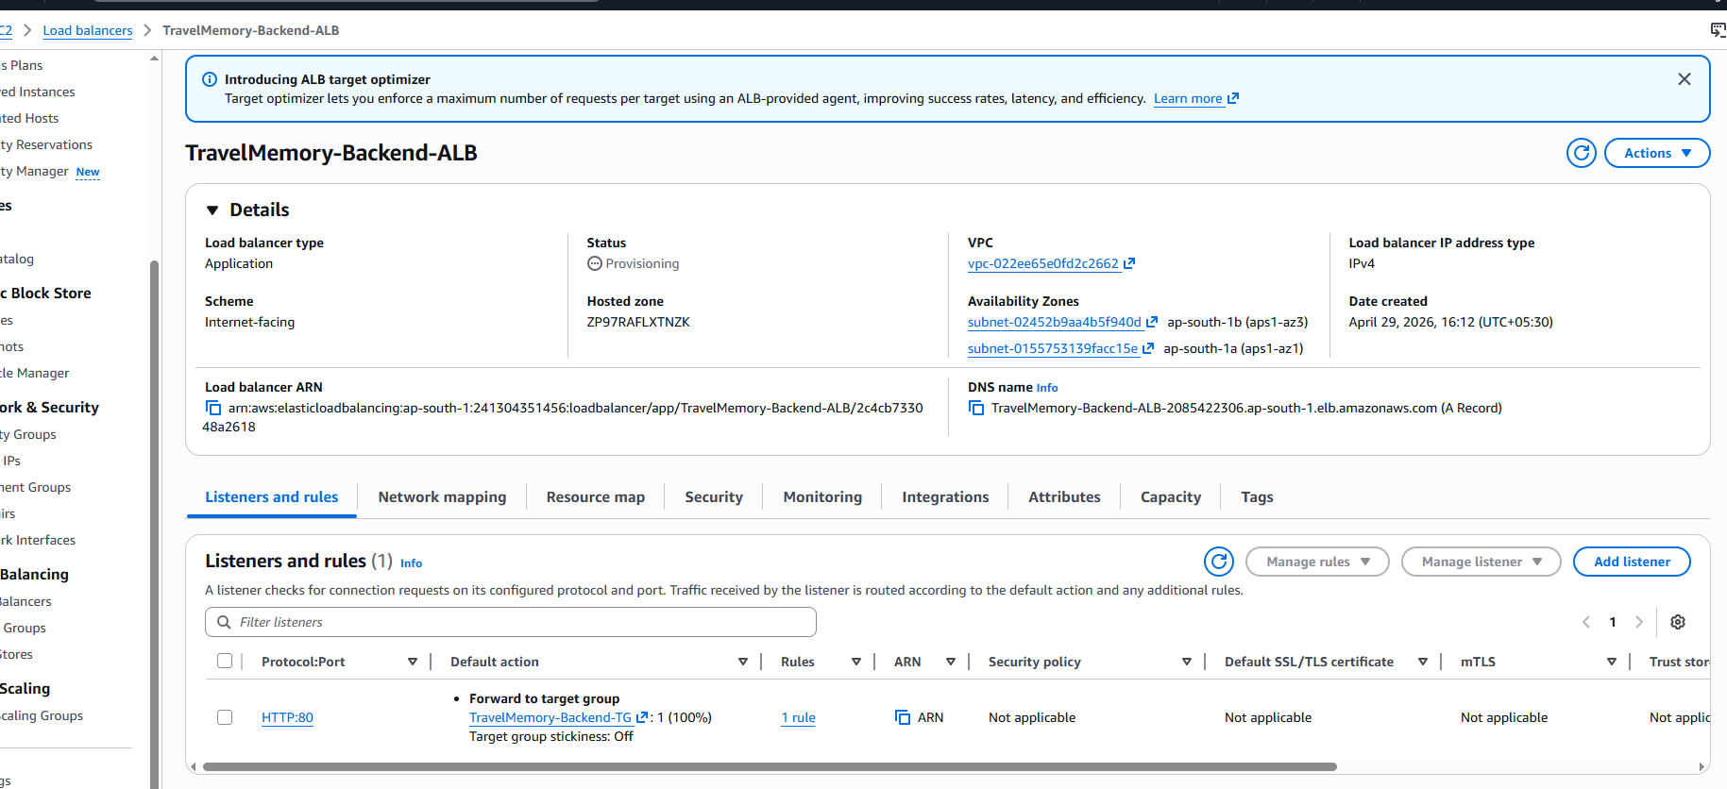
- Click Create. Note the DNS name (e.g., travelmemory-backend-alb-xxx.us-east-1.elb.amazonaws.com).
TravelMemory-Backend-ALB-2085422306.ap-south-1.elb.amazonaws.com

Repeat for the Frontend ALB (TravelMemory-Frontend-ALB).
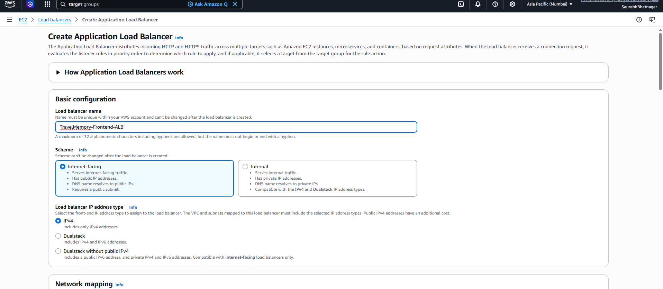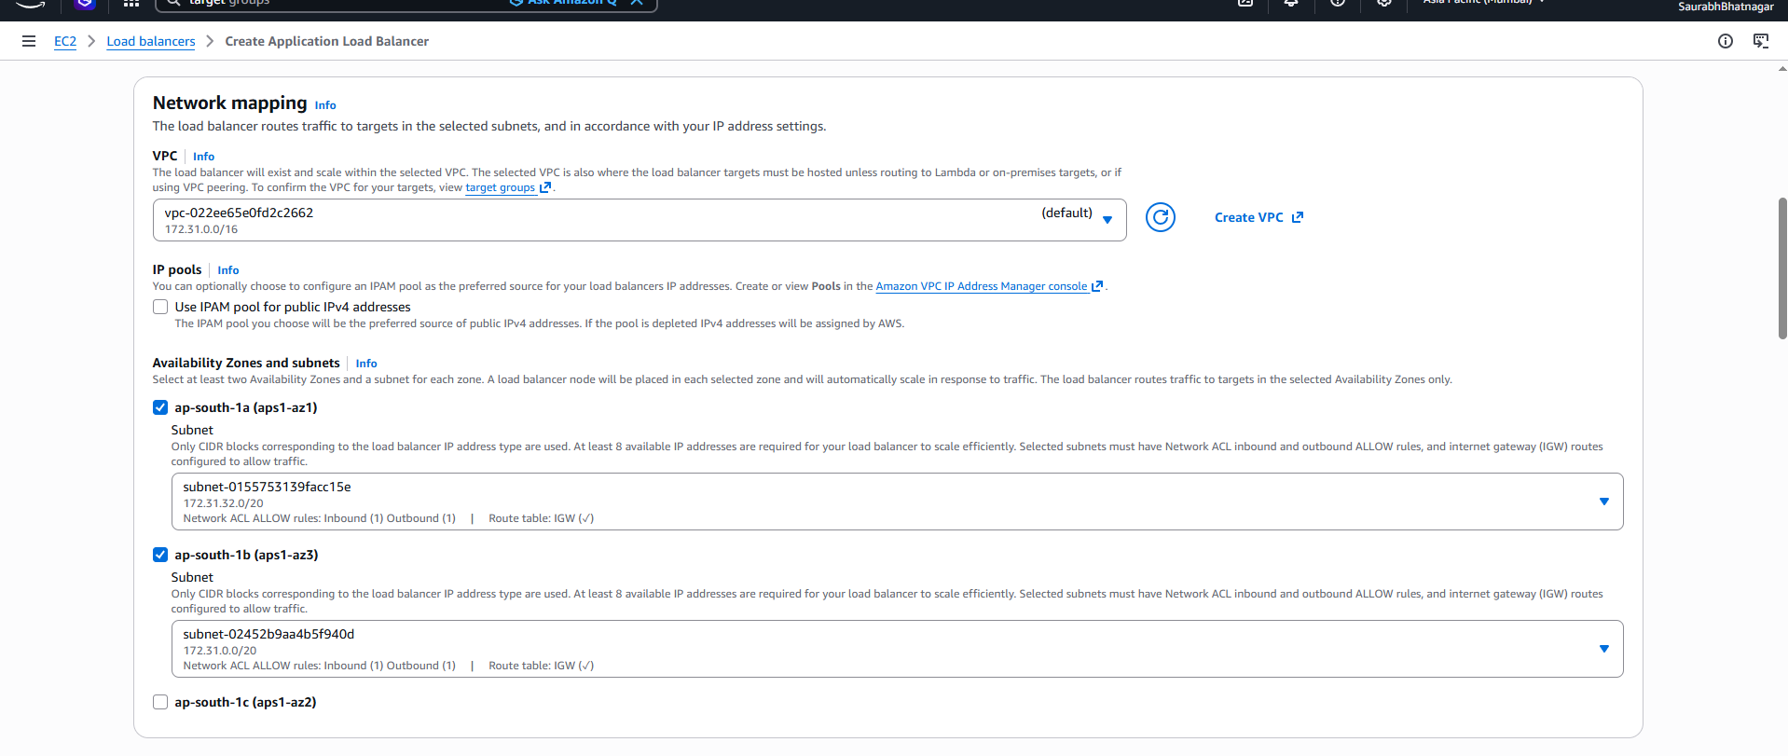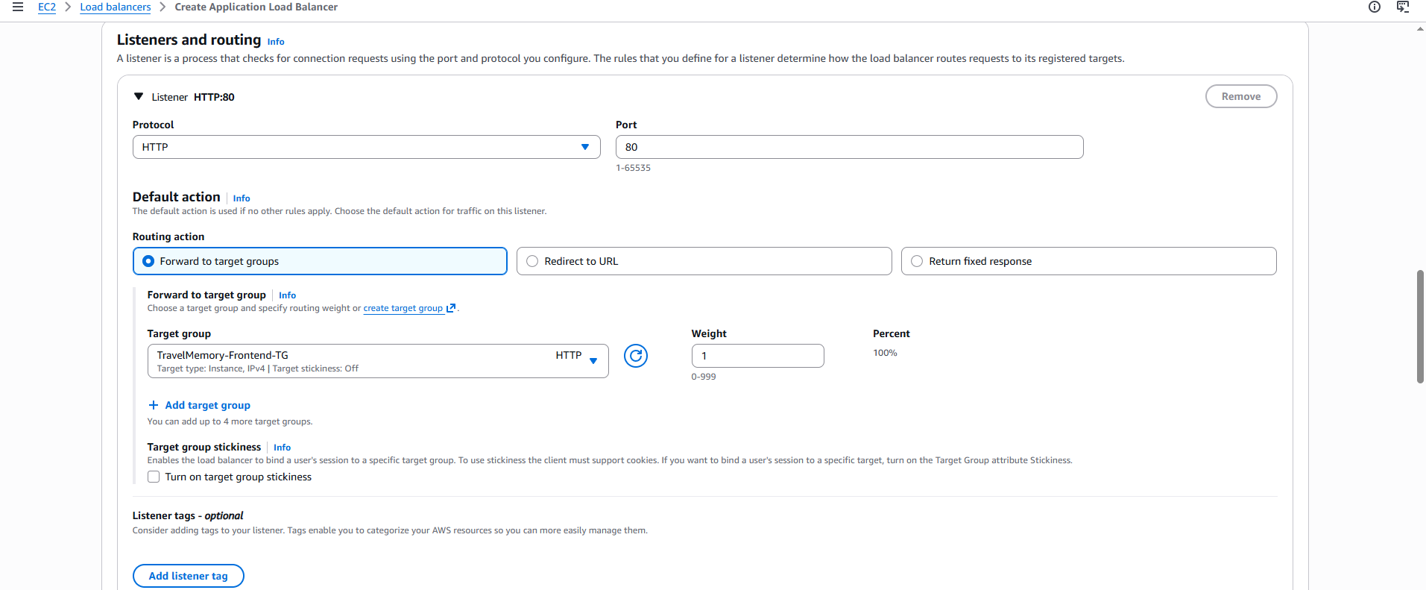
Update urls.js with the Backend ALB DNS name (replacing the direct IP).
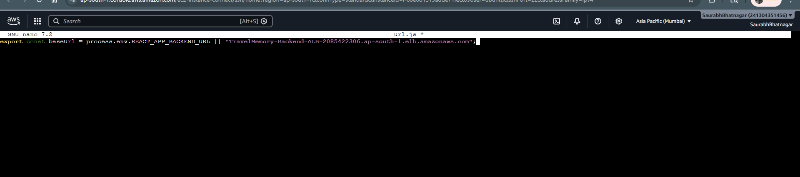
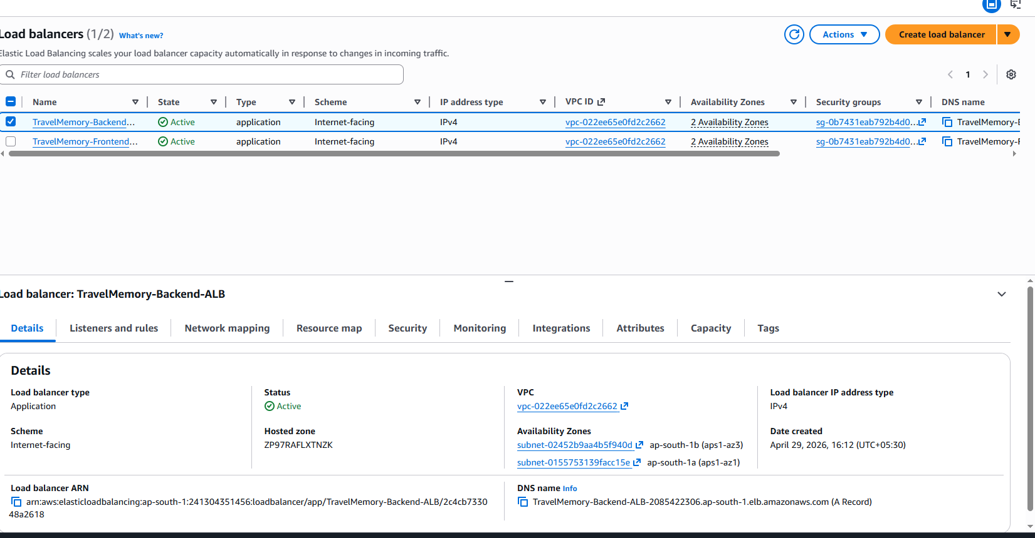
Note: Screenshot Point: Screenshot of both ALBs in "active" state with their DNS names visible.

6. Task 4 — Domain Setup with Cloudflare

6.1 Add Your Domain to Cloudflare
- Log in to your Cloudflare dashboard at https://dash.cloudflare.com.
- Click Add a Site and enter your domain name.
- Select the Free plan (sufficient for this project).
- Cloudflare will scan for existing DNS records.
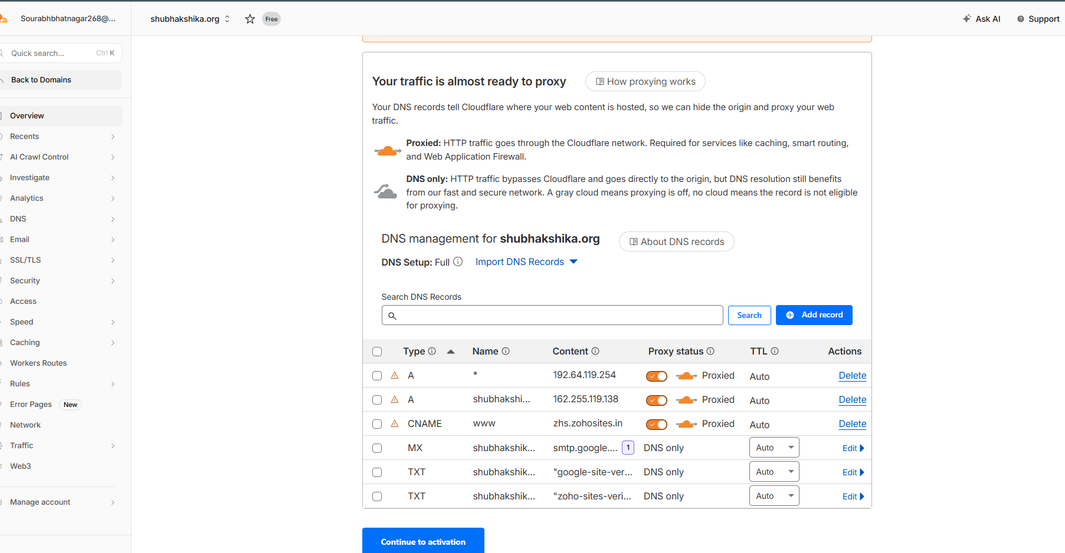
- Update your domain registrar's nameservers to the two Cloudflare nameservers provided.
- Wait for nameserver propagation (up to 48 hours, usually within 1 hour).
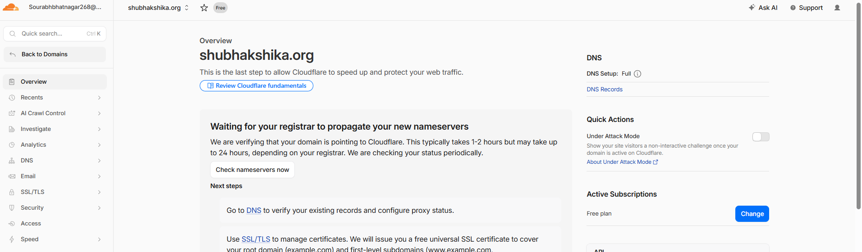

Note: Screenshot Point: Screenshot of the Cloudflare dashboard showing your domain with "Active" status.

6.2 Create DNS Records
In Cloudflare DNS settings, create the following records:

Type | Name | Content / Value | Purpose
CNAME | api | <Backend-ALB-DNS-Name> | Maps api.yourdomain.com to backend LB
A | @ | <Frontend-EC2-Public-IP> | Maps yourdomain.com to frontend EC2
CNAME | www | yourdomain.com | Maps www to root domain

Note: A CNAME record cannot coexist with other records on the same name. Cloudflare supports "CNAME flattening" at the root (@), but use an A record for the root domain pointing to your frontend IP. Use a CNAME for api subdomain pointing to the backend ALB DNS name.
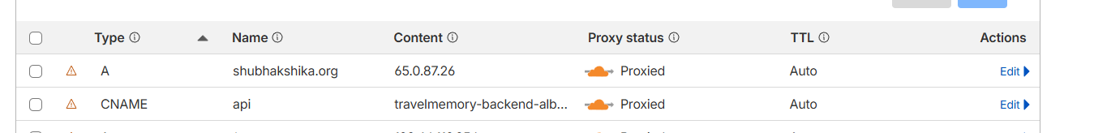
Enable Cloudflare's proxy (orange cloud icon) for DDoS protection and CDN caching.
Note: Screenshot Point: Screenshot of the Cloudflare DNS settings page showing all three DNS records with their values.
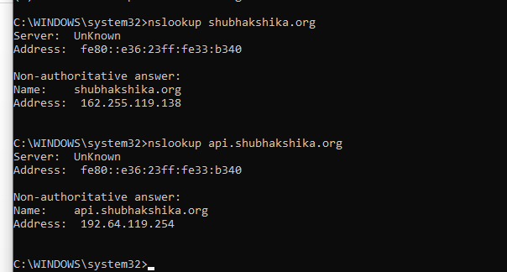
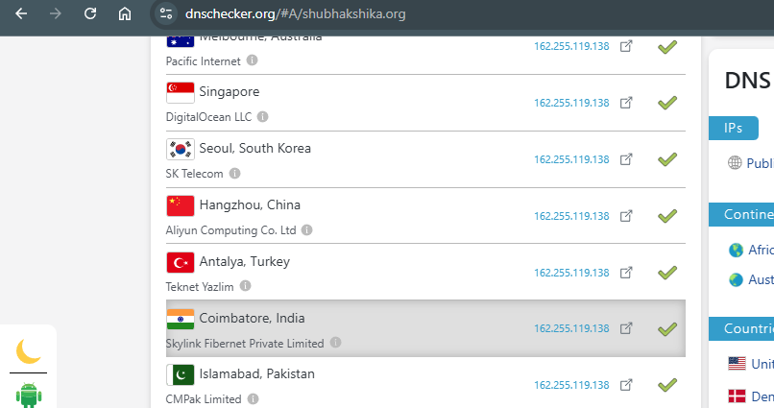 Verify DNS propagation:
nslookup yourdomain.com
nslookup api.yourdomain.com
# Or use: https://dnschecker.org

7. Security Best Practices
- Never commit .env files to Git. Add .env to .gitignore immediately.
- Restrict SSH access (port 22) to your specific IP address only in Security Groups.
- Use AWS Secrets Manager or Parameter Store for production credentials instead of .env files.
- Enable HTTPS using AWS Certificate Manager (ACM) free SSL certificate on the ALB.
- Set Cloudflare SSL/TLS mode to "Full (strict)" once HTTPS is configured.
- Regularly rotate MongoDB credentials and JWT secrets.
- Enable AWS CloudWatch monitoring and set up billing alerts.
- Use private subnets for backend instances and expose only the ALB to the internet.
- Enable Cloudflare's "Under Attack Mode" if DDoS is detected.

8. Troubleshooting
Problem: 502 Bad Gateway from Nginx
Solution: The Node.js backend is not running. Run: pm2 status. If stopped, run: pm2 restart travelmemory-backend.

Problem: Cannot connect to MongoDB
Solution: Check your MONGO_URI in .env. Verify the MongoDB Atlas IP whitelist includes your EC2 public IP. Test with: node -e "require('./config/db.js')"

Problem: Frontend shows blank page
Solution: React routing issue. Ensure Nginx config uses try_files $uri $uri/ /index.html for SPA routing.

Problem: Health checks failing in ALB
Solution: Verify the application responds on the health check path. Check Security Group allows traffic from the ALB on port 80.

Problem: Cloudflare DNS not resolving
Solution: Nameserver propagation may take up to 48 hours. Verify at your registrar that Cloudflare nameservers are set correctly.

Problem: CORS errors in browser
Solution: Add CORS middleware to the Express backend: npm install cors, then app.use(cors({origin: "https://yourdomain.com"}))

9. Architecture Diagram Description
The deployment architecture should be created in draw.io (https://draw.io) and exported as a PNG/SVG for submission. The diagram should depict the following flow:

- User Browser: Initiates HTTPS request to yourdomain.com.
- Cloudflare: Acts as DNS resolver and CDN/WAF layer. Routes traffic based on record type.
- Frontend ALB (AWS): Receives HTTP/HTTPS traffic and distributes to frontend EC2 instances.
- Frontend EC2 Instances (x2): Run Nginx serving the React build files. Nginx proxies /api calls to the backend.
- Backend ALB (AWS): Routes API requests to backend instances. The CNAME api.yourdomain.com points here.
- Backend EC2 Instances (x2): Run Node.js/Express on port 3000, proxied by Nginx on port 80.
- MongoDB (Atlas/EC2): Stores all travel memory data. Connected via MONGO_URI over TLS.

Key draw.io elements to include:
- Internet globe icon for "User"
- Cloudflare logo / orange cloud
- AWS ALB icon for both frontend and backend load balancers
- EC2 instance icons in two separate groups (frontend cluster, backend cluster)
- MongoDB icon for the database
- Arrows showing request flow with labels (HTTPS, HTTP, port numbers)
- AWS region boundary box encompassing all AWS resources
- Color coding: blue for frontend, green for backend, orange for Cloudflare

10. References
- TravelMemory GitHub Repository: https://github.com/UnpredictablePrashant/TravelMemory
- AWS EC2 Documentation: https://docs.aws.amazon.com/ec2/
- AWS Application Load Balancer: https://docs.aws.amazon.com/elasticloadbalancing/latest/application/
- Nginx Reverse Proxy Guide: https://nginx.org/en/docs/beginners_guide.html
- PM2 Process Manager: https://pm2.keymetrics.io/docs/
- MongoDB Atlas: https://www.mongodb.com/docs/atlas/
- Cloudflare DNS Documentation: https://developers.cloudflare.com/dns/
- draw.io Diagram Tool: https://app.diagrams.net/

